Lab 3:

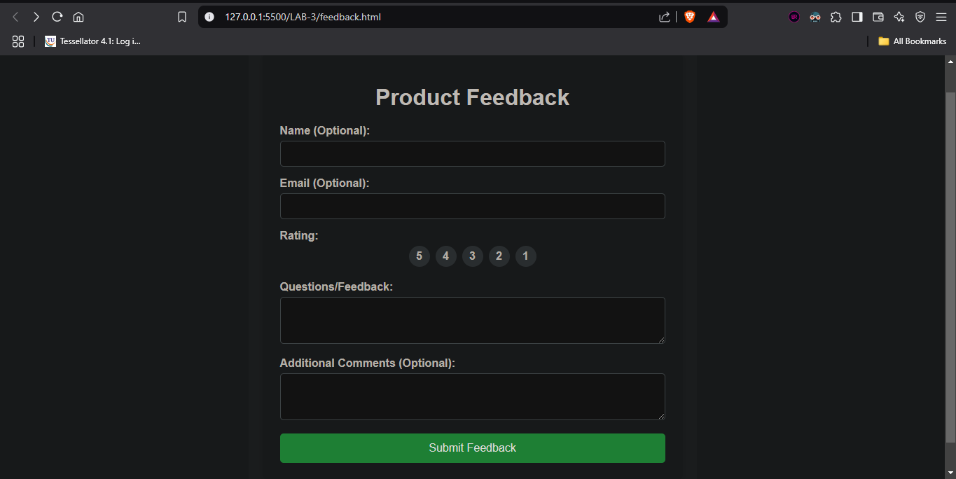

Github link :

<https://github.com/vipulchinmay/FEWD_LAB>